

FACULTY OF TECHNOLOGY AND ENGINEERING
DEVANG PATEL INSTITUTE OF ADVANCED TECHNOLOGY AND RESEARCH

DEPARTMENT OF INFORMATION TECHNOLOGY

A.Y 2026-27 Semester-3

LAB MANUAL

CSUC201: Fundamentals of Data Structure and Algorithms



Practical 1
Practical AIM:
To implement fundamental array operations.
Practical 1.1
Problem Definition:
A bakery prepares n items every morning and places them in a display row. At the end of each hour, the leftmost item is moved to the rightmost position to make room for fresh stock at the front. Given the initial row and the number of hours h, print the final display order.
Describe the approach you used. How does it behave when h is very large, say 10 million? Is there a way to get the correct result without performing the operation h times?
Problem faced:
I had difficulty understanding how to rotate an array and how h % n works.
Solution:
I used a temporary variable to store the first element and shifted the remaining elements to the left. Then I placed the first element at the end. I learned that h % n reduces unnecessary rotations.
Output:
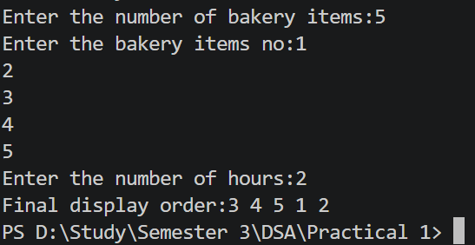
Practical 1.2
Problem Definition:
A library issues books to students and records each book's ID every time it is borrowed. At the end of the month, the librarian wants to find all books that were borrowed more than once, as those need priority restocking. Given the borrowing log, print all such book IDs.
Describe the approach you used. How many times does your solution scan the data? If the library had 100,000 borrow records, would your approach still be practical? Can you think of a way that requires fewer passes?
Problem faced:
I had difficulty finding duplicate book IDs and understanding why two loops are needed.
Solution:
I used two loops to compare each element with the other elements. If two elements are the same, the duplicate book ID is printed. This helped me understand how elements are compared.
Output:
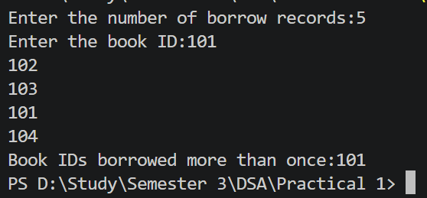
Practical 1.3
Problem Definition:
A school newspaper editor wants to highlight the most impressive word from a submitted article on the front page. The word is chosen simply by length — the longest one wins. Given a sentence, print the winning word and how many letters it has.
Describe the approach you used. What does your solution do when two words have the same length? Is that behavior intentional, and can you think of a way to handle it explicitly?
Problem faced:
I had difficulty finding the longest word in a sentence and counting its characters.
Solution:
I used getline() to take the complete sentence and separated the words using spaces. I compared each word with longest and used length() to find the number of characters.
Output:
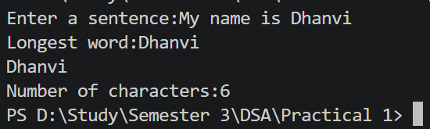

Key Questions:
1. [Problem 1] The display order repeats itself after a certain number of hours regardless of how large h gets. Without trying any specific example, explain why this repetition is inevitable and what determines when it first repeats.
ANS:
The display order repeats because the array contains a fixed number of elements, n. After every n rotations, the array comes back to its original order. So, rotating more than n times only repeats the same arrangements.
This makes repetition inevitable because there are only n possible rotation positions. The value h % n gives the effective number of rotations. The first repetition occurs after n rotations.
2. [Problem 2] If the same book ID appears three times in the log, should it appear once or three times in your output? Does your solution handle this correctly, and how would you verify it?
ANS:
If the same book ID appears three times, it should appear once in the output. The purpose is to identify which IDs are duplicated, not to print every repeated occurrence. If we simply compare elements using two loops, the same ID may be printed multiple times. To handle this correctly, we should make sure an ID is printed only once. We can use an additional check or a set to avoid duplicate output. To verify it, we can test an input where one book ID appears three times. The expected output should contain that book ID only once.
3. [Problem 3] The editor later decides that punctuation attached to a word (e.g. “hello,” or “great!”) should not count toward its length. How would this change your solution, and at which step would you handle it?
ANS:
If punctuation should not count toward the word length, we need to remove punctuation before checking the length. For example, hello, should be treated as hello. This change should be handled while reading or separating each word. We can check each character and ignore punctuation marks such as ,, ., !, and ?. After removing punctuation, we compare the cleaned word with the current longest word. Then we use length() on the cleaned word. This ensures that only actual letters are counted.

Github Link:
https://github.com/dhanvi-219/FDSA/tree/main/Practical%201

